
Perry Johnson Registrars, Inc.

Procedure for Publicizing/Advertising Certification and Use of the PJR Logo, Standard Licensing Body Logos and Accreditation Body Symbols

The credibility of third-party certification depends upon the certified organization’s appropriate use of the certification body logos, standard licensing body logos and its accreditation body symbols and avoidance of any misleading statements in publicizing certification.

This procedure describes the proper way of publicizing a certified organization’s certification, as well as proper use of the PJR logo, standard licensing body logos and accreditation body symbols. It outlines the steps PJR will take when certification is not publicized appropriately or marks are misused.

Care must be taken to guarantee that the public is not misled regarding levels of accreditation for individual standards or perceived associations of PJR with other organizations providing related services. PJR is an independent certification body and is not a part of any organization providing consulting services.

Amendment Record

Amendment of this and any other controlled document is governed by the Document and Data Control procedure PRO-4.

Date | Details | Current Rev. Level
04/04/17 | Over-all spelling corrections, change to logo approval contact, and change to ema approval contact email. | 13.2
07/03/17 | Appendix C - Accreditation body name changed (JIPDEC to ISMS-AC) and its symbol changed accordingly. | 13.3
9/26/17 | FSSC 22000 Logo – FSSC V4.1 Requirements changed | 13.4
2/22/2018 | EMA logo and proposal for authorization - 1. EMA Updated the Logo. 2. Employee rotation | 13.5
2/28/2018 | Added section on Gluten Free Certification Program, Removed ANAB’s old symbol in 12.0 Appendix B | 13.6
4/25/2018 | Appendix C – Changed the accreditation body name from JIPDEC to ISMS-AC. | 13.7
2/20/2019 | Appendix C – updated to meet the Guidance for Use of ISMS-AC IMS Accreditation Symbol (JIP-IMAC510-5.0) | 13.8
6/17/19 | 12.0 Appendix B, added the following verbiage: “If you choose to use more than one accreditation body logo, a PJR logo must be used next to / adjacent each accreditation body logo.” | 13.9
8/26/19 | Removed Gluten-Free Certification Program logo instructions, removed references to ISO 17065. | 14.0
10/30/2019 | Strengthened verbiage regarding use of ema logo (page 19). | 14.1
3/3/2020 | Changed RIOS logo to follow ISRI logo requirements V 3.0 | 14.2
4/27/2020 | Changed JAB logo to follow JAB N410:2020 | 14.3
5/27/2021 | Added information regarding new ANAB & UKAS logos. | 14.4
8/2/2021 | Regarding R2: added reference (3.13 and 3.14) to the latest revision of the SERI License CB Agreement and SERI COP Advisory 20 (respectively), added the R2v3 logo and clarification for R2 logo usage (depending on the standard) | 14.5
9/1/2021 | Difference of image file format of JAB’s accreditation symbol in the statement from what PJR actually provides resolved. “electronic file in the BMP format” changed to “electronic file format,” and the fact that there is no distinction between web-specific use and for printing reflected. Each part name of JAB accreditation symbol corrected according to Rule for Accreditation Symbol Use JAB N410:2021 Ver.19 | 14.6
10/28/2021 | Update Accredia’s provisions on page 16 and 17, according to the latest revision of Accredia’s Regulations for the Use of the Accredia Mark (RG-09 rev. 10) | 14.7
11/30/2021 | Updated the R2v3 logo to reflect a correction distributed by SERI | 14.8
4/11/2022 | Action 6.4 on page 7 and on page 10, contact changed to Lisa Arpino (larpino@pjr.com) | 14.9
5/06/22 | CLD symbol added | 15.0
2/1/2023 | Updated the SERI logo usage appendix | 15.1
4/4/2023 | Updated Appendix B with ana dded paragraph on the use of the UNI mark | 15.2
8/29/2023 | One paragraph added in Appendix B to ensure that the certification scope must be listed with logos  Updated Appendix C. Removed detailed ISMS-AC IMS Accreditation Symbol usage and added to see PRO-3 Japanese for details.  Added Appendix D to see PRO-3 Japanese for JFSM symbol usage. | 15.3
Perry Johnson Registrars, Inc.

Procedure for Publicizing/Advertising Certification and Use of the PJR Logo, Standard Licensing Body Logos,
and Accreditation Body Symbols

PRO-3

1.0 Scope

This document describes the procedures PJR follows to control the certified organization’s publicizing of its certification and use of the PJR logo, standard licensing body logos and accreditation body symbols.

2.0 Responsibility

The Audit Logistics Manager is responsible for ensuring that certified organizations receive the appropriate materials regarding publicizing their certification and use of the PJR logo, standard licensing body logos and symbols of its accreditation bodies. The Programs and Accreditations Manager is responsible for enforcing the appropriate contractual restrictions governing their use and publicizing of the organization’s certification.

Any use of PJR’s accreditation body symbols for PJR publicity must be approved by the Programs and Accreditations Manager, President or appropriate designee to ensure proper usage.

In Japan, CEO has the responsibility of President provided herein.

3.0 References

3.1 EN 45012 The European Standard for Bodies Certificating Suppliers' Quality Systems

  - ISO/IEC 17021 Latest Revision

3.3 PJR-1, Quality Manual

3.4 Accreditation/Oversight Body-specific regulations for use of accreditation marks (ANAB, JAB, UKAS, ACCREDIA, ema, and IATF)

3.5 PRO-1 series, Certification Procedure

3.6 ISO Guide 27: Guidelines for corrective action to be taken by a certification body in the event of misuse of its mark of conformity

  - F-3 series, Agreement For Certification (and all versions of such agreement)

  - ISO/TS 22003 Latest Revision
  - ISO/IEC 27006 Latest Revision

  - E-Stewards Standard Latest Revision

  - R2 Code of Practices Latest Revision

  - Recycling Industry Operating Standard™ (RIOS™) Logo Usage Rules / ISRI Services Corporation

  - SERI License Agreement Latest Revision

  - SERI COP Advisory 20 Latest Revision

4.0 General

4.1 In accordance with the requirements of ISO/IEC 17021, ISO/TS 22003,
ISO/IEC 27006, the ANAB Criteria for Accreditation and others, PJR possesses a logo by which PJR’s certified organizations may make others aware of their certification by means of various forms of publicity.

4.2 PJR’s certified organizations are made aware of certain regulations governing appropriate publicizing of its certification and the proper use of the PJR logo, standard licensing body logos, and accreditation body symbols it has been awarded via this document and the F-3series.

4.3 For the product/service certification according to RT 29, certified clients are allowed to use ACCREDIA’s symbol in conjunction with the PJR logo, on the instrumental equipment used to deliver the service, adding the term “certified service”. In case of services only partially certified, that term needs to be integrated with the necessary limitations.

4.4 It is vital that PJR requests corrective action when the publication of certification and/or the usage of its logo, standard licensing body logos or accreditation body symbols are in the wrong manner in any way, in order to maintain the marketplace's high level of confidence in the validity of the certification and, by extension, the reputations of PJR, its accreditation bodies and PJR’s certified organizations.

4.5 PJR’s certified organizations are not to use its certificate or certification in such a manner as to bring the PJR into disrepute and does not make any statement regarding its certification which may be considered misleading.

4.6 The IAF MLA recognizes accreditation bodies that meet its requirements. This is a worldwide agreement for the purpose of the recognition of the quality of products and services for the international market. For additional information please visit http://www.iaf.nu. All of PJR’s accreditation bodies are IAF-MLA signatories.

5.0 Handling of the Registration Certificate
5.1 PJR is the sole authority by which PJR Registration Certificates are granted. All certificates remain the property of PJR.
5.2 Registration Certificates must be surrendered or destroyed upon re-issue of replacement certificates or withdrawal / cancellation of certification.
5.3 When appendixes are attached to the Registration Certificates, they must be used in conjunction with the Registration Certificates.
5.4 When the customer request a copy of the Registration Certificate, it must easily be identified as a reproduction. (Example: a black-and-white reproduction stamped “COPY”).

5.5 PJR shall issue a certificate(s) indicating full conformance of the e-Steward with all applicable requirements of the Standard when, and only when PJR has confirmed that the e-Steward has a valid and current Licensing Agreement in place with the e-Stewards Program Administrator for the use of the e-Stewards name and logo, and all non-conformances have been cleared.

The certificate issued shall bear the PJR logo, the accreditation body symbol and the e-Stewards logo (as provided by BAN to PJR in conjunction with its Licensing Agreement). No unaccredited e-Steward certificates may be issued. Rules for use of the logo are described in the Licensing Agreement.

5.6 PJR shall issue a certificate(s) indicating full conformance to R2 with all applicable requirements of the Standard when, and only when PJR has confirmed that the R2 company has a valid and current Licensing Agreement in place with the SERI Program Administrator for the use of the R2 name and logo, and all non-conformances have been cleared.

The certificate issued shall bear the PJR logo, the accreditation body symbol and the R2 logo (as provided by SERI to PJR in conjunction with its Licensing Agreement). No unaccredited R2 certificates may be issued by PJR. Rules for use of the logo are described in the Licensing Agreement and R2 Code of Practices.

6.0 Publicizing of Certification Procedures

6.1 Certified organizations are allowed to publicize the certification only after PJR grants certification. The Programs and Accreditations department responds to inquiries regarding publication of certification. PJR furnishes certified organizations with camera-ready artwork of the PJR Logo, standard licensing body logos, if applicable, and accreditation body symbols. Certified organizations are allowed to use logos and accreditation body symbols only after PJR’s permission to use them. In principle, PJR considers furnishing the PJR logo, standard licensing body logos, if applicable, and accreditation body symbols to certified organizations as granting permission for proper use.

6.2 PJR auditors examine the control of Registration Certificate, certified organizations’ use of logos and accreditation body symbols as well as the publicizing of certification at every audit.

6.2.1 Improper publicizing of certification, improper use of the PJR logo, standard licensing body logos, and accreditation body symbols include, but is not limited to:

- placing the PJR logo, standard licensing body logos and accreditation body symbols on certified organizations’ products or product packaging
- using them in any other manner that implies that products are certified by PJR and its accreditation bodies
- forging an original copy of Registration Certificate
- making color copies of the certificates, including scanning color copies of the certificates. EXCEPTION: It is permissible for certified organizations which hold valid certificates to display color reproductions of their certificate on their website. In this case, the reproductions must be prevented from forgery. (Example: set to invalid download / print)
- publicizing certification or using logos and/or symbols on business cards, signboards, on websites with different addresses other than the address certified (difference must be communicated on cards, signboards, or websites)
- publicizing certification or using logos and/or symbols on business cards, signboards, on websites with products or services other than the certified ones (differences of such products and services must be communicated on cards, signboards, or websites.)
- use on stationery when:

The PJR logo is not displayed and the standard licensing body logos and accreditation body symbols are
- prominence is shown with the logo of one body over another
- accreditation body symbol used more than once for each accreditation
- publicizing the scope of activities of the certified organization that misleads the public
- advertising certification in any way that might mislead the reader about the status of a certified organization.
- Using out-dated/obsolete versions of the logos and/or symbols

6.3 Should PJR find, by means of audits, field report, or other means, that:

a) A non-certified organization has used PJR's logo or the accreditation body symbols in any way, or

b) A certified organization has possibly violated PJR regulations regarding use of certification with respect to use,
c) A certified organization publicizes its sites, products and services in such a way as to suggest that they are certified.
The Programs and Accreditations Manager requests corrective actions in accordance with this procedure.

6.4 If any client wishes to use Perry Johnson Registrars’ name in any publications such as newspaper articles, magazine articles, electronic media or similar publications, you must acquire prior approval from HQ. In the U.S., please send your proposals to the Accreditation Department contact responsible for these matters via e-mail at larpino@pjr.com. In Japan, please contact the Tokyo Office Accreditation Department. For publications in other languages, please contact your scheduler to coordinate the approval process.

7.0 Corrective Actions

7.1 PJR immediately begins corrective action proceedings upon discovery of improper publicizing of certification, a misuse of the PJR logo, standard licensing body logos or accreditation body symbols.

7.2 Non-certified organization found to be using the PJR logo, standard licensing body logos or accreditation body symbols, including former certified organizations, receive one written warning, via registered mail return receipt requested, to cease and desist the improper publicizing of certification or use of logos and/or symbols, with a specific deadline for acquiescence. Should the misuse continue, the Programs and Accreditations Manager refers the matter to the President and possibly to the appropriate legal counsel for action. The Programs and Accreditations Manager may also notify concerned regulatory and accreditation bodies of the specifics of the matter.

7.3 Certified organizations who violate PJR regulations regarding the publicizing of certification are instructed to implement effective corrective action in writing, either via nonconformity report, registered letter from the President, or other means.

7.4 The Programs and Accreditations Manager follows up on such corrective action requests and obtains written agreement from the certified organizations to

a) Discontinue the improper use at once;
b) Notify any person or organization that may have been misled in any way, shape, or form by the misuse, of the corrective action and the reasons therefore, copying PJR’s Programs and Accreditations Manager and/or President in writing.

7.5 The Programs and Accreditations Manager may, at his/her discretion, follow up on these steps by scheduling a special surveillance of the certified organizations’ facility; inquiring of recipients of the certified organizations’ corrective action letters, or other means that may be appropriate.

7.6 In any event, the incidence of misuse is followed up at subsequent surveillance audits of the certified organization.

8.0 Escalation

8.1 Certified organizations who refuse to discontinue improper use of the PJR logo, standard licensing body logos or accreditation body symbols or improper publicizing of certification; who persist in violation of PJR's Regulations regarding publicizing of certification; who misuse the logos and/or symbols repeatedly in different ways, and/or who fail to promptly and affirmatively implement corrective actions as instructed, are subject to having their certification suspended or withdrawn.

9.0 Other Provisions

9.1 Upon successful certification, certified organizations will be issued a “Certificate of Registration” that will clearly reference the specific scope of certification.

9.2 Prior to use of the e-Stewards® mark, the certified organization shall execute BAN’s Marketing and Licensing agreement and pay all associated fees.

9.3 Prior to use of the R2 logo, the certified organization shall execute SERI’s Licensing agreement and pay all associated fees.

Accredited Scopes

PJR will not issue a certificate in any scope area for which it has not received accreditation.

11.0 Appendix A
Guidelines for Publicizing Your Certification

- Don’t use ISO’s logo.

- Don’t adapt or modify ISO’s logo for your use.
- Don’t excerpt from audit reports provided by PJR for publicizing of certification.

- If you want to use a logo or wish to publicize your success, ask PJR for permission to use its logo, or guidance on publicity.

- In the ISO 9001 or ISO 14001 contexts, “certified” (and “certification”) and “registered” (and “registration”) are equivalent in meaning and you can use either term.

- Don’t say your organization has been “accredited”. PJR is “accredited” – our clients are “certified” or “registered”. For example, the word “accredited” appears on the ANAB symbol depicting that the certification body (PJR) issuing the certificate of registration is accredited by ANAB to do so within that particular scope of operation.

- Don’t use “ISO certified”, or “ISO certification”.

- Use instead “ISO 9001 certified”, “ISO 9001 certification”, or “ISO 14001 certified”, or “ISO 14001 certification”. PJR would prefer that the revision year of the standard is included. If you choose not to do so, this is acceptable. If you include the revision year, it must be updated as appropriate.

- Don’t display PJR logo or any applicable accreditation body symbols on products, product labels, or product packaging, or in any way that may be interpreted as denoting product conformity. This applies to laboratory test, calibration or inspection reports.

- It is permissible to use a statement on product packaging or in accompanying information that your Organization’s management system is certified. Product packaging is considered as that which can be removed without the product disintegrating or being damaged. Accompanying information is considered as separately available or easily detachable. Type labels or identification are considered as part of the product. The statement shall in no way imply that a product, process or service is certified by this means. The statement shall include the reference to:

  - identification (e.g. brand or name) of the certified organization
  - the type of management system (e.g. quality, environmental) and the applicable standard; and
  - identification of PJR as the Certification Body issuing the certificate

Example: This product is manufactured by ABC plant of XYZ company certified to ISO 9001 (Quality Management System) by PJR

- Don’t give the impression in any context that ISO 9001 or ISO 14001 certifications are product certifications or product guarantees. Do not use the PJR or any Accreditation Body Logos in any way in product catalogs that may imply product certification.

- When including a reference to ISO 9001 or ISO 14001 certifications in product-related information, including advertisements, do not do so in such a way that ISO 9001 or ISO 14001 certifications may be interpreted as being product certifications or product guarantees.

- Be accurate and precise about the scope (the extent) of your organization’s ISO 9001 or ISO 14001 certifications, as far as both the activities and geographical locations covered by the certifications are concerned.

- For 16949, the only use of the IATF logo is as displayed on the certificate issued by PJR. The IATF logo must be in equivalent prominence to any other logos on the certificate.

- Always use the most current version of accreditation body symbols and/or standard licensing body logos. If in doubt, contact the Accreditation Department via e-mail at larpino@pjr.com or via phone at 800-800-7910.
12.0 Appendix B
Regulations for Use of the PJR Logo, Standard Licensing Body Logos and Accreditation Body Symbols

The logos and symbols that may be used by a PJR-certified organization is/are indicated on the actual PJR Certificate of Registration. They are found in the lower left hand corner of the certificate.

No logos or symbols can be used on any legal documents (e.g., contracts, checks, calibration reports, purchase orders). They may be used on promotional materials and business stationery.

No logos or symbols can be used in such a way as to suggest that any product, process, or service that was not a part of the registration audit is certified.

Logos and symbols must be used in a way to clearly express the certification scope.
For example, when it is not clear only with a logo or symbol to which standard a management system is certified, the standard must be clearly listed, and when a certification scope is limited, the scope must be clearly listed.

Logos or symbols shall be reproduced in a size that makes all of the features clearly distinguishable.
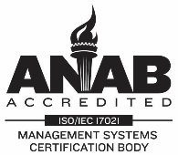
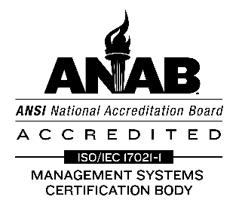
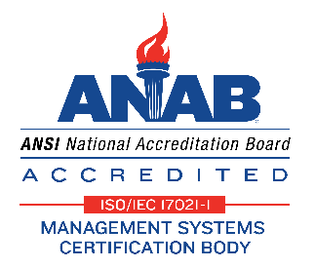
Perry Johnson Registrars Inc.
Perry Johnson Registrars, Inc. (PJR)

The PJR logo may be used independently or in combination with the symbols of PJR’s accreditation bodies (if the certified organization is entitled to use them). If you choose to use more than one accreditation body logo, a PJR logo must be used next to / adjacent each accreditation body logo.

If the logo is reproduced in a single color, the color may be black or a single color belonging to the house-style of the certified organization, if the color provides sufficient contrast to make the mark clearly identifiable. If reproduced in more than one color, the flag’s field is to be reproduced in reflex blue or PMS 287 blue (or a four-color tint-mix approximating reflex blue); the flag’s stripes shall be reproduced in PMS 185 red (or a four-color tint-mix approximating PMS 185 red), and the type shall be reproduced either in a blue that matches the flag’s field or in black.

ANAB (USA)

The ANAB symbol may only be used in combination with PJR’s logo, and the ANAB symbol may not be larger or more conspicuous than the PJR logo.

The ANAB symbol shall be reproduced only in black on a white or light-colored background or in blue (PMS 286 or equivalent) and red (PMS 485 or equivalent). When used for marketing material, letterhead, business cards, etc., on a clearly contrasting background; in a size that makes all features of the symbol clearly distinguishable; without distortion of its dimensions.

While new versions of the ANAB logo are now available (please see below), the rules for use have not changed. (The prior version of the ANAB logo is pictured to the left). A version of the new logo must be in use by January 1, 2025, at which time the previous version of the logo will be obsolete and shall not be used. Images of the black and white and color logo are below.

Japan Accreditation Board for Conformity Assessment

Composition of Former Accreditation Symbol
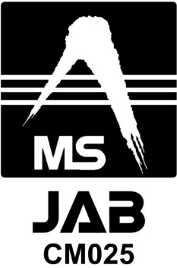 | Accreditation number  -  Graphic in the upper part of Accreditation Symbol  Graphic part of Accreditation Symbol  The former JAB’ accreditation symbol above can be used till February 29, 2024 and it cannot be used after March 1, 2024.

Composition of New Accreditation Symbol

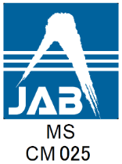 | Graphic in the upper part of Accreditation Symbol  Accreditation Symbol  Accreditation scheme code  Accreditation number  The JAB accreditation symbol may only be used in combination with PJR’s logo, and the JAB symbol may not be larger or more conspicuous than the PJR logo. The JAB accreditation symbol must be used with the accreditation number. Letters of JAB and accreditation number must be clearly legible. The accreditation number is “CM025”.  When using the JAB accreditation symbol for printed materials and on the website, a reproduction of the printing proof (the electronic file format) provided by PJR must be used.. (These proofs were originally provided by JAB to PJR.) The proof must be used in an integrated manner as provided by PJR. It must not be broken down, recomposed, etc., to be used.  Graphic in the upper part shall be reproduced in blue (DIC 579 (CMYK: C90 M62 Y21 K0, RGB: R0 G98 B157)). Note: although symbol colors are different in former and new accreditation, there is no problem as long as colors specified by JAB are used. In addition, black, gray, gold, silver are accepted to be used as supplemental colors. White part of the symbol shall be in solid to provide sufficient contrast to make the mark clearly identifiable from the surrounding color. Accreditation scheme code and accreditation number shall be reproduced in black. Notwithstanding the above, if the accreditation symbol is reproduced on printed materials printed in a single color, the symbol may be reproduced in the same ink color of the printed materials. In this case, the color shall provide sufficient contrast to make the entire symbol clearly identifiable from the surrounding color.  When the accreditation symbol is printed in reduced or enlarged size, proportion of the symbol, logo and accreditation number must remain the same as the provided proof and must not be changed. Furthermore, the symbol must not be altered to degrade the image from the provided proof such as to display it in lower resolution.  The certified organization may not use the JAB symbol unless authorized to do so.  When you provide a reproduction of the printing proof of the JAB accreditation symbol to your subcontractor(s) to create printed materials and/or website, you must have a list of such subcontractors and present it to PJR when requested.

United Kingdom Accreditation Service (UKAS)

The UKAS accreditation symbol may only be used in combination with PJR’s logo and must be enclosed in a box as indicated below. Any of the four versions of the UKAS logo may be used in this format. The UKAS symbol may not be larger or more conspicuous than the PJR logo. The UKAS symbol may be used on stationery and publicity materials or other items relevant to the certificate.
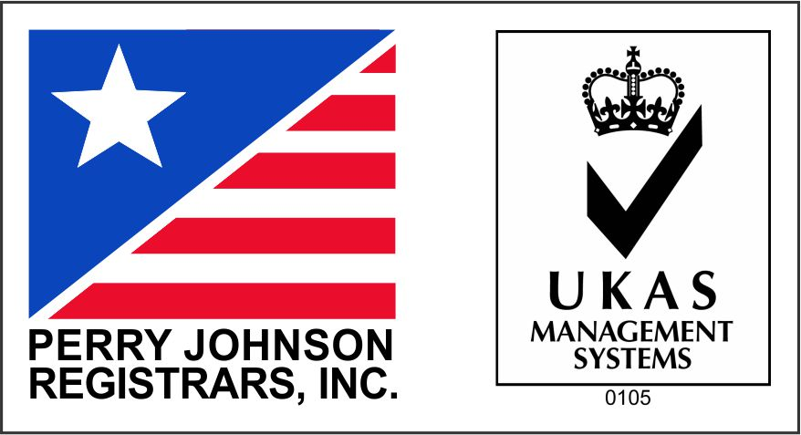
Rules for UKAS symbol use stem from the National Accreditation Logo & Symbols: Conditions for use by UKAS and UKAS Accredited Organizations URN 11/673.

The UKAS symbol may be reproduced in either black and white or the color scheme. If the reproduced in color, the following rules must be followed:
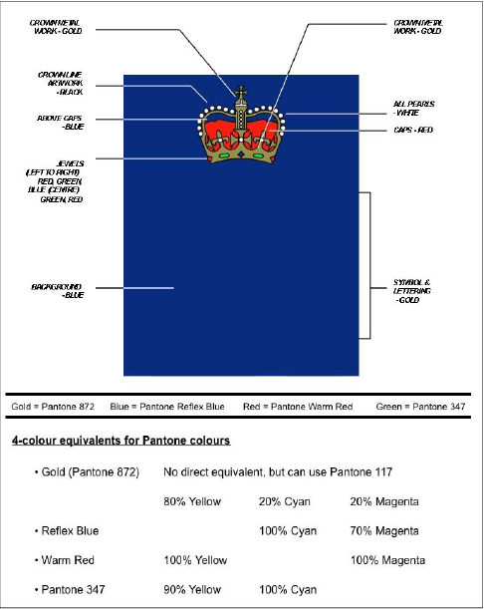

The four permissible versions that will be required beginning January 1, 2024, are as seen below (as well as an example used in conjunction with the PJR logo):


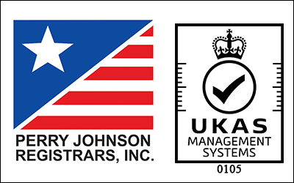

The color codes for the new Purple are as follows:
• PANTONE 2685 C
• RGB 51 0 114
• HEX/HTML 330072
• CMYK 97 100 0 19

Where the UKAS symbol is reproduced electronically, the following applies:

a) the UKAS symbol is to be reproduced so that infilling does not occur

b) degradation and/or distortion of the UKAS symbol graphic is avoided.
The UKAS symbol shall normally have a minimum height (excluding the accreditation number) of 20 mm. Any enlargement or reduction shall retain the same proportions as those of the masters reproduced in this publication. The UKAS symbol and accreditation number shall be considered as a single entity for purposes of enlargement or reduction.

In exceptional circumstances, which are usually dictated by reason of space limitation or cost, the UKAS symbol may be reproduced at a reduced height. However, irrespective of the height of reproduction, the UKAS symbol must be legible, with no filling. When the UKAS symbol is printed on an unfolded portion of stationery sized no greater than A4, it shall be displayed in a size no larger than 30 mm high. On larger portions of unfolded stationery the size may be proportionately increased.

The UKAS symbol shall not be used in such a way as to suggest that UKAS has certified, or approved, any product or any service supplied, or in any other misleading manner. Additionally, the symbol shall not be used in such a way as to imply that UKAS accepts responsibility for activities carried out under the scope of certification.

The UKAS symbol shall not be displayed on vehicles, except in publicity material containing the mark as part of a larger advertisement. The UKAS symbol shall not be placed on notices, labels, documents or written announcements affixed to or otherwise appearing on goods or products. This restriction also applies to primary packaging and promotional materials. The symbol shall not be displayed on buildings or flags. The certified organization may not use the UKAS symbol unless authorized to do so.

While new versions of the UKAS logo are now available (please see above), the rules for use have not changed. A version of the new logo must be in use by January 1, 2024, at which time the previous version of the logo will be obsolete and shall not be used.

ACCREDIA:

In the section below, the following definitions have been used or referenced:

Logo: Registered Symbol to be used by the accreditation body (AB). Only the AB can make use of its logo on its documents.

Mark: A symbol that the AB gives for use to the accredited bodies to indicate their accreditation status. It consists of the logo which relates to the abbreviation of the scheme and the accreditation number.

The use of the ACCREDIA mark by the organizations with a certified quality management system is only permitted in conjunction with the mark of PJR, as shown in Figure 1 and according to the rules of this procedure. The ACCREDIA mark used by customers of accredited bodies is oval and has the name “ACCREDIA” in it and a reference to "The accreditation body” with the shape of Italy in the center. It does not include the letters of the accreditation schemes and registration numbers, or references to the MLA. The alternative to the graphic solution described above (ACCREDIA mark in conjunction with the Certification Body mark), is to put the bilingual or monolingual sentence “Organismo accreditato da ACCREDIA – Certification Body accredited by ACCREDIA” in proximity of the PJR mark (above, underneath or next to it).

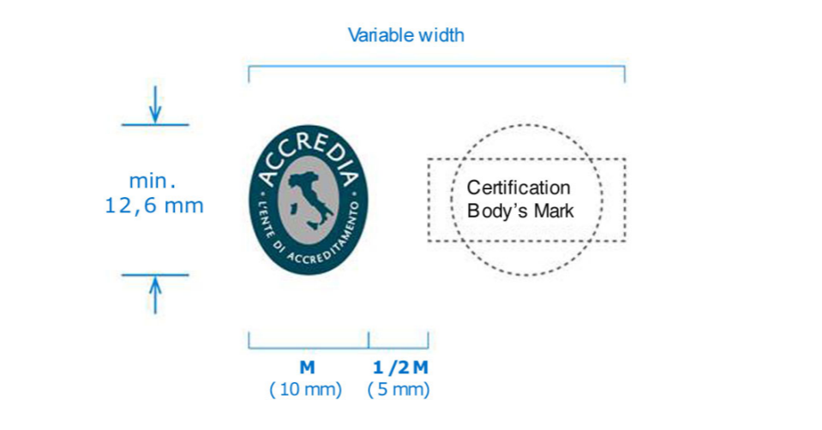

Figure 1

In addition to general guidelines on the use of the Accreditation mark mentioned in the introductory pages of this procedure, please also consider the following:

It is not permitted to use the Accredia Mark in such a way as to give the idea that ACCREDIA has certified the organization’s management system.

It is not permitted to use PJR and Accredia’s mark (alone or together) on products either made or supplied by the certified organization, on packaging or in accompanying documentations. However, it is possible to use a declaration such as “Organization with a quality management system certified by PJR”.

It is not permitted to use PJR and Accredia’s mark (alone or together) on business cards.

It is not permitted to use the ACCREDIA mark and PJR mark in any type of technical documentation that could reference the product in any way (ex. declarations of conformity for CE marking).

A certified organization may use the accreditation mark, together with PJR mark, on letterhead and documents in general (except for any technical documentation concerning the products manufactured) or on goods and equipment that are instrumental to the implementation of the processes falling within the scope of the certified management system (such as vehicles, buildings, gowns, overalls and the like) except for items which constitute the subject of specific product certification, whether mandatory or regulated (machinery, equipment, personal protective equipment , etc.). For use on goods and instrumental resources, the pairing of the two marks should be completed with the addition of a sentence such as "organization with certified management system, indicating the reference of the certified system (i.e. ISO 9001:2015) .

The test reports and/or calibration certificates issued by laboratories, and/or the PT reports issued by a PTP and/or documents relating to a reference material issued by an RMP, as well as biological materials reports issued by a biobank, whose quality management system has been certified by PJR, are never to display the PJR Mark and the ACCREDIA Mark, with or without reference to accreditation of PJR.
For test reports issued by testing laboratories, the calibration certificates issued by calibration lab, the testing reports issued by PTPs, the documents relating to a reference material issued by RMPs, and/or biological materials reports issued by a biobank, and the relative quotation documents, it is possible to use the wording “Organization with certified management system”, indicating the type of MS (e.g. quality) as well as the applicable standard.

The accreditation mark to be used by certified organizations has two versions: one of two colors (ACCREDIA blue and ACCREDIA gray), and a monochrome version in black and white. The color coding of ACCREDIA Blue is Pantone 548, CMYK: C.90% - M.5% -% Y0 - K.80% RGB: R.0 - G.55 - B.81; HTML: 003851; while color coding of ACCREDIA gray is: Pantone 429, CMYK: C.20% - M.10% -% Y10 - K.20% RGB: R.179 - G.188 - B.192; HTML: b3bcc0
In the monochrome version of the black and white logo, the Italy symbol must be colored with 30% black.

The minimum width permitted of the mark is:
Figure 2

The text composition font for graphic files for the printing press is ITC STONE SANS STD.
The text composition font for shareable digital documents (MS Word, MS PowerPoint etc..) is Verdana.

Note 1: solutions other than those described in the above instructions must be authorized by ACCREDIA.
Note 2: The logo ACCREDIA is protected by law and therefore its malicious or fraudulent use will be pursued according to the terms of the law, where applicable.

Use of the UNI Mark (UNI/PdR 125:2022 certification only)

The UNI Mark can only be used in conjunction with the PJR (licensed CB) mark, which is evidence of the certified conformity of the client organisation against regulatory requirements.

The use of the UNI mark is considered inappropriate when it does not comply with the "Rules for the use of the UNI mark” and/or when the overall message is misleading, deceptive to the relevant recipients, or may undermine public trust or damage UNI's reputation.

The use of the UNI Mark is inappropriate when the organisation has not obtained or not yet obtained certification from PJR, when certification has been withdrawn or when its use of the Mark has been suspended.

The UNI mark shall be used in conjunction with the PJR mark. Any inappropriate use as per the Regulations for the Use of PJR's Mark (PRO-3 procedure) is therefore considered incorrect.

The UNI Mark may not be displayed on products or packaging, or in such a way that it may be interpreted as an indication of the product's conformity.

The UNI Mark can also be used on documents, marketing material, etc. as long as this is not in contrast with the regulations for the use of PJR's mark (PRO-3 procedure).

Organisations certified against UNI/PdR 125:2022 may refer to the certification as follows: "Organisation ....... (name or brand) with a Gender Equality Management System certified under UNI/PdR 125:2022 by the Certification Body Perry Johnson Registrars Inc. with UNI Mark".

The UNI 'Organisations' Mark can be granted to organisations assessed as compliant against UNI/PdR 125:2022, and must be used in combination with PJR's Mark, as follows:

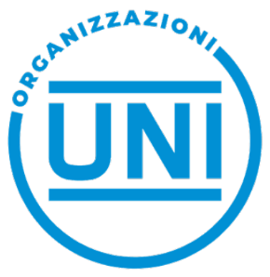

The UNI 'Organisations' mark can also be used in combination with the PJR mark and the Accredia mark, as follows:

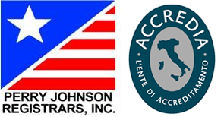

The combined use of PJR's mark and the UNI "Organisations" mark shall be approved by PJR from the certificate's issue date.

It should be noted that the UNI Conformity Mark "Organisations" is intended to certify that the requirements of a certified management system are identified by UNI through the publication of reference standards or practices.

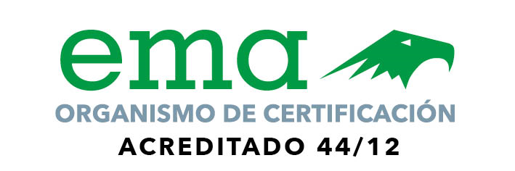

The accredited certification body is authorized to use the ema accreditation symbol on certificates of registration ONLY. Neither the certification body nor the certified organization (client) is authorized to use the ema accreditation symbol for any other purpose. There are absolutely no exceptions to this rule. The only acceptable use of the ema logo is on the certificate given to the certified organization (client) by PJR. The certified organization (client) may not reproduce, enlarge, or enhance the certificate in any way.
In exchange, the client may use the following phrase with prior authorization:

Certification completed by Perry Johnson Registrars, Inc. accredited by ema, with accreditation number 44/12.

Proposals for authorization should be submitted to kmedel@pjr.com

FSSC 22000

 | The FSSC 22000 logo may only be used in conjunction with the PJR logo on printed matter, literature, business cards, website and promotional material subject to the design specifications below. It may not be used on a product, labeling or packaging or in any way as to suggest that PJR has certified or approved any product, product or service, or in any other misleading way. Mentioning possession of a FSSC 22000 certificate or making any reference such as “Produced in a FSSC certified company” on a product label, packaging, etc is not allowed.  PJR will audit the use of the FSSC 22000 logo by certified organizations during every initial, surveillance and re-certification audit. Any non-conformance associated with the misuse of the logo will require remedial action to correct the use of the logo as well as corrective action for future use.  It must be reproduced in specified colors and in a size which makes all features of the logo clearly distinguishable.  Color specifications:  Green: Pantone 348 U: CMYK = 82/24/76/7 RGB = 32/132/85, #218455  Grey: 60% black: CMYK = 0/0/0/60, RGB = 135/135/135, #87888a  Use of the logo in black and white is permitted when all other text and images are in black and white.  The size of the FSSC 22000 logo must not differ from the size of the PJR’s or accreditation body logos and they must always appear together. The use of the logo and protection of its copyright is controlled by the Foundation FSSC 22000 and the logos can be obtained through the secretariat of the Foundation via info@fssc22000.com

The Sustainable Electronics Reuse & Recycling (R2) Standard v3

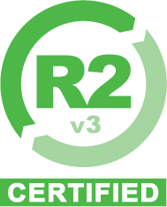 | The R2 logo must be obtained from PJR and used in a manner consistent with the requirements in the R2 Code of Practices. The correct logo must be selected, based on the version of the Standard to which the Client Facility is certified: R2v3. R2 Certified Client Facilities are required to refer and adhere to logo usage and advertising rules as documented in the SERI R2 Facility Agreement, specifically Appendix C—Mark and Guidelines for Use.  If the logo is reproduced, it must be unaltered in any manner other than size, except that it may be displayed in black and white. The logo must always be displayed in a size which is clear and readable.  The logo may only be used by certified entities that have a licensing agreement in effect with SERI. The logo shall only be used in relation to the specific facility certified and shall not be displayed in a manner that could be perceived as implying that the entire company is R2 certified if it is not. This includes displaying the R2 logo on corporate websites or other media that are not specific to the location(s) certified.  The logo may only be used in relation to the activities or scope certified. When all operating activities are not certified, the R2 logo may only be displayed in conjunction with the activity(s) certified. The R2 logo may not be displayed on corporate websites or other media which are not specific to the scope certified.  The logo must be promptly removed from all publications upon suspension, expiration or withdrawal of the active R2 certification, including but not limited to website usage, email signatures, printed marketing, business cards, etc.
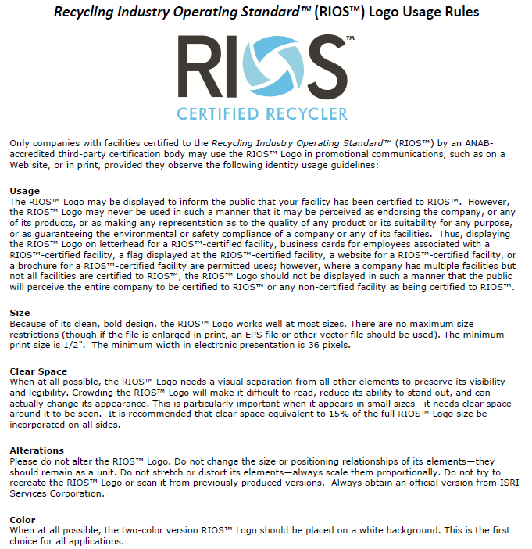
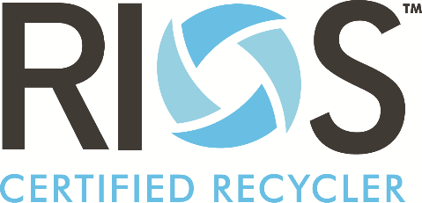
13.0 Appendix C
Summary of PJRJ logo/ Accreditation Body Symbols Use Regulations
Specific to Japan Division (ISMS-AC)

Appendix C is applicable to certification of JISQ 27001 and ISO/IEC 27017 provided by Japan Division (PJRJ) under the accreditation by ISMS Accreditation Center (ISMS-AC). See PRO-3 Japanese for details.

14.0 Appendix D
Summary of PJRJ logo/ Accreditation Body Symbols Use Regulations
Specific to Japan Division (JFSM)

Appendix D is applicable to certification of JFS-B provided by Japan Division (PJRJ) under the accreditation by Japan Food Safety Management Association (JFSM). See PRO-3 Japanese for details.

